Mandates in Folketinget

**Authors: Jakob Tinmahan , Kresten Clausen, Smilla Larsen**

Keywords: Folketinget, mandates, Jordskredsvalget

**Main Report**

Introduction

We want to investigate how the mandates in the Folketinget have developed since the “Jordskredsvalget” in 1973. Our research question is: How did the mandates in the elections for the Danish Parliament change from 1973-2001 and why?

Politics in Denmark has changed since the beginning, and 1973 became a turning point in Danish politics, because it changed the amount of parties that could be voted on. So, we wanted to understand how much it has changed since the turning point.

*a.* *Problem Orientation and Motivation*

We want to see if we can find a common thread throughout history since the “Jordskredsvalget” in 1973. We also wanted to see how Danish politics have changed throughout the years.

*b.* *Background/Context*

Before 1973, the norm had been for only four to five parties to be represented in the Danish Parliament. All that changed with the 1973 general election, which was later nicknamed “Jordskredsvalget.” Folketinget went from having four to five parties to now having 10 parties in the Danish Parliament. There are many reasons why this happened in 1973. One of these reasons is the oil crisis in 1973. It hit in autumn as a consequence of the Yom Kippur war in the Middle East, because the Arabs limited their oil export and increased oil prices heavily, this would lead to a higher percentage of unemployed, because of price reductions as an outcome of economic decline.[1] Socialdemokratiet reached an agreement with Socialistisk Folkeparti on housing policy and taxes, but this lead to conflict within the Socialdemokratiet party. That meant Ernhard Jacobsen split from the party, to found his own party called “Centrum-Demokraterne”. Socialdemokratiet had a minority in the parliament, and this led to an early election - which ended up as the “Jordskredsvalget”, where Poul Hartling became prime minister as a representative from Venstre.[2]

Another one of the reasons is the class equalization, due to the rapid economic development of the 60s, combined with the welfare state's redistribution of goods. The traditional class divisions were blurred. For example, the working class had started to move into their own house and had a car, like the classic saying in Danish "villa, Volvo and poodle" (villa, volvo, vovse) and became the middle class. With this comes new priorities/problems and therefore the foundation for new parties began to emerge. [3]

Some of the reasons why the election ended the way it did include the European Parliament (EF) at the time, which was the subject of much debate. The disagreement was big, and since none of the old parties had represented the "No" side properly, there was a simple opportunity for some of the new parties to show their dissatisfaction. This was precisely what parties such as the Danmarks Kommunistiske Parti and the Retsforbundet, both of which had a strong no campaign, exploited. Socaldemokratiet in particular was divided as a party on this point, as a wing in S got permission to make a campaign for the No side. [4]

The youth uprising of 1969 along with grassroots movements and hippie culture had a massive flourishing and helped shape the red wing, while the previous VKR government had left more disappointment than happiness and therefore helped shape the new liberal right wing in favor of some of the new parties as KRF and FP. All this added to the latest technology of the time, namely TV, which everyone followed because there was only a single channel at the time and was therefore a great promotional channel. Especially for party leaders like Mogens Glistrup and Erhard Jakobsen who had understood TV as a new opportunity to get very close to the voters.[5]

*c.* *Expectation/Hypothesis*

Our hypothesis is that there is a big change in the development of the parliamentary basis throughout the period from “Jordskredsvalget” in 1973 to 2001, because when “Jordskredsvalget” happened in 1973, 6 new political parties joined the election as potential mandates.

Methods

*a.* *Research Design*

Our approach is that we have an expectation that the mandates will be distributed mostly in red. We found data from [ft.dk](http://ft.dk), where we saw how the mandates were distributed from 1953-2022. We quickly decided that we wanted to research how the mandates changed since the “Jordskredsvalget” in 1973, because that was a turning point in Danish politics, where five new parties were elected to the Danish Parliament, so there were ten parties. Before there had only been five big parties that were elected every election. So Danish politics became more interesting and varied after the “Jordskredsvalget” in 1973.

Then we talked about the research problem and hypothesis, so we could investigate.

Based on what we already knew about Danish politics, we chose five elections to look into. And then we started data processing. We made an excel sheet, where we took the data we needed from the dataset, and organized it, so that it would be neat and tidy. The dataset from Folketinget’s own website wasn’t tidy and therefore we needed to make our own dataset.

Then we put our reworked dataset into R-Studio, and started working with it. We made an animation-graph that shows how the mandates are distributed throughout the years, and then we marked down the five years we are looking into; 1973, 1977, 1984, 1994 and 2001.

Then we made the five charts that show how the mandates are distributed between the different parties only in the years we chose, and color coded them for easier reading and recognition.

*b.* *Software Framework and Materials*

Smilla Larsen wrote the code for this project on her one year old Macbook Air A3113, 16Gb. It runs the macOS Sequioa 15.4.1. She worked in the version 2024.12.1+563 of RStudio and in R (4.4.2) and used the packages tidyverse (2.0.0) and Dplyr (1.4.4).

Jakob Tinmahan wrote the code for Rstudio (V. 2024.12.1+563) on his Macbook Air M3 (2024) with MacOS V15.3.2 and used tidyverse v.2.0.0 and Dplyr 1.4.4

Kresten Clausen wrote the code for this project on a Macbook Air, 16Gb RAM. MacOS Sequioa 15.4.1. V. 2024.12.1+563 of RStudio and in R (4.4.2).

*c.* *Data Acquisition and Processing*

We used the dataset “Folketingsvalgene 1953-2022” from Folketingets website: [ft.dk](http://ft.dk), that we processed and selected five years that we wanted to focus on.

On ft.dk, they have a page called Open Data, which is their open data found in the databrowser oda.ft.dk, working in Odata, where the data is available for download in XML or JSON formats.

Folketinget’s data is pr. 6. December 2018

- Metadata about cases and documents in the parliamentary work in the Parliament's hall and a committee from October 2013 and after. Including data about the Folketingets and the committees composition in the different periods and meetings.

- Data about documents containing links for PDF-files on ft.dk.

- Data about actual members of the Folketing, containing a field with the members biography in XML-format.

- Reports from Folketinget’s negotiations in XML-format.

We chose these 5 years, because they are important years in danish politics:

* In 1973 “Jordskredsvalget” took place and where the four old parties, for the first time, suffered defeat. The old parties were “Socialdemokratiet”, “Radikale Venstre”, “Venstre” og “Det Konservative Folkeparti”. After the “Jordskredsvalget”, 5 new parties were represented in the Danish Parliament.[6]
* In 1977 there was not supposed to be an election, but the prime minister Anker Jørgensen, chose to hold a general election, because of the Socialdemokratiet minority government, and had great difficulty getting his proposals implemented. But when the election took place, Socialdemokratiet won, and therefore Anker Jørgensen became Prime Minister again.[7]
* In 1894 the parliament was conservative and neoliberal with Poul Schlüter as Prime Minister. Poul Schlüter was popular among the people, and because of Socialdemokratiets “policy of cut-backs”, people were afraid that Denmark would see “American conditions”.[8]

Multiple of his governments were coalition governments, and he cooperated with smaller parties in the center. The two largest parties were “Det Konservative Folkeparti” and “Venstre”.[9]

* In 1994 the government Prime Minister was Poul Nyrup Rasmussen who was a politician from Socialdemokratiet. Socialdemokratiet and Radikale Venstre cooperated for a long period, until Poul Nyrup Rasmussen stopped as Prime Minister in 2001.[10]
* In 2001 Venstre won the election by far. It, once again, became the largest party in Folketinget since 1920. The Prime Minister was Anders Fogh Rasmussen, and his politics as prime minister distanced themselves from neoliberalism and ideology.[11]

Findings

We have through the use of Rstudio made an animation, and multiple charts showing how the parliament's mandate distribution has changed through the years. The codes for the charts and the animation can be found in the Githubs listed at the end. We can see through the first chart (Chart A) how the S (Socialdemekratiet), have been on top of the charts for the most part of our selected period, but in 2001 they got overtaken by V (Venstre), which can be seen clearly on the last chart (Chart F). The first chart also shows how the V-party had a sudden rise between 1975, but at the next election in 1977 it got the same amount of mandates.

*Chart A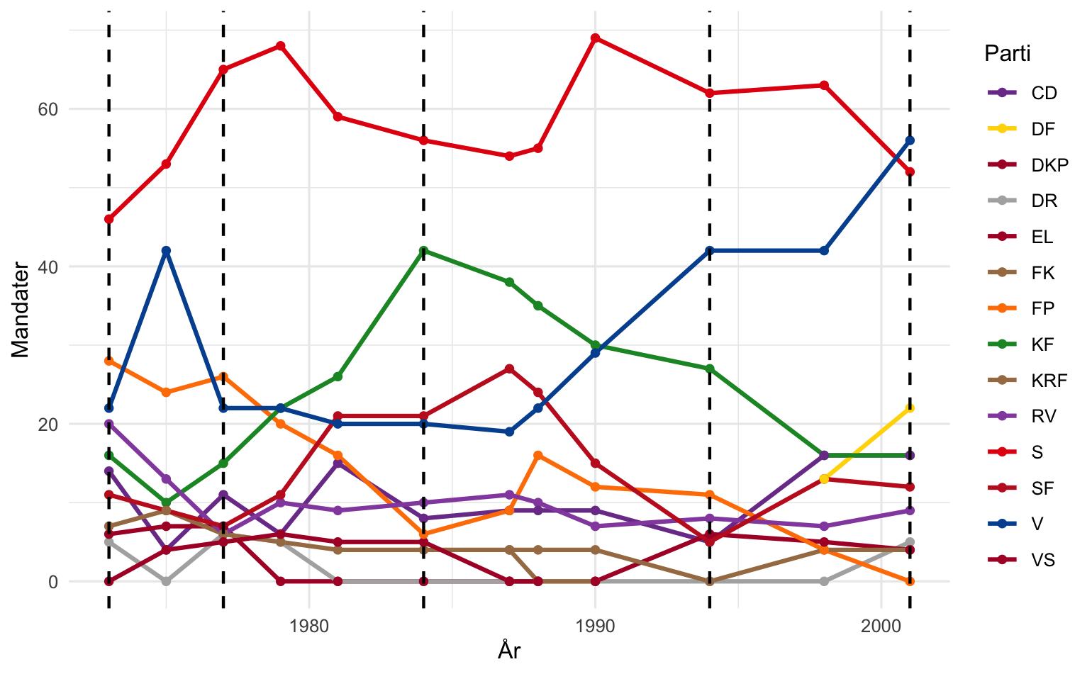*

In 1973 (Chart B) S got the most mandates, but FP (Fremskridtspartiet), KF (Konservative Folkeparti), RV (Radikale Venstre) and V still got a lot of

candidates, but nowhere near the same amount of mandates as S got. With Fremskridtspartiet, there is a blue majority

*Chart B*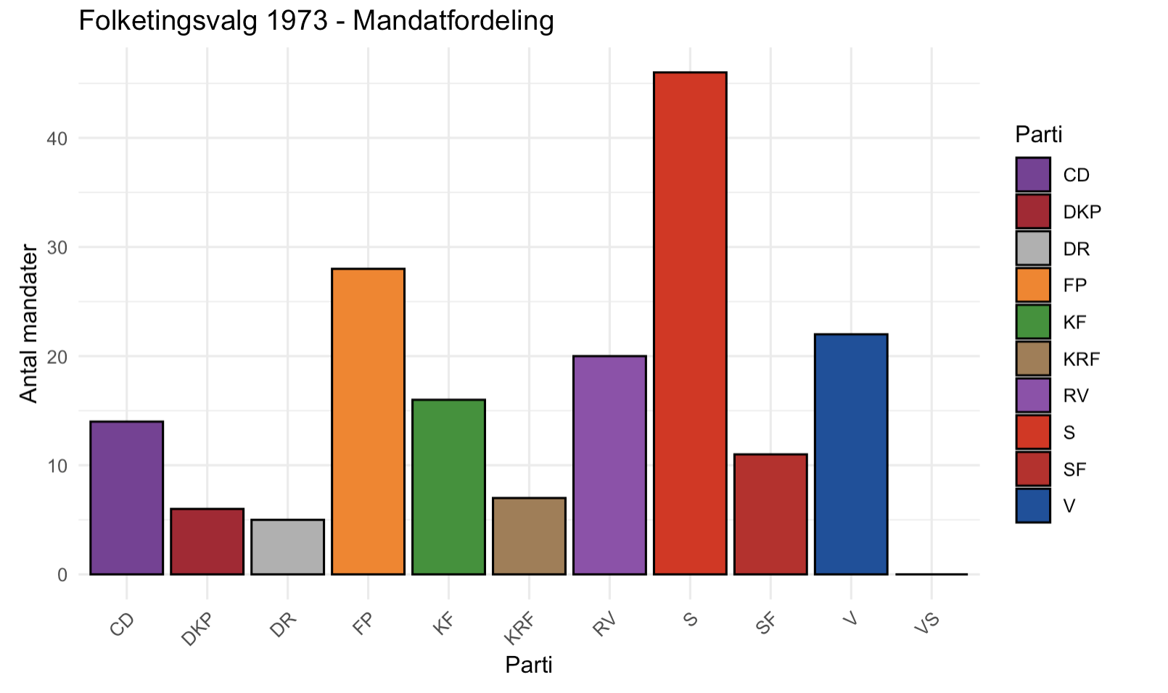

In 1977 (Chart C) S still got the most mandates, but no other party is close to the same number of candidates that S got. The only 2 parties that are “close” are FP and V, who do not match the amount of S, even if combined. In this sense, there is a red majority, but Venstre also joins the government.

*Chart C*

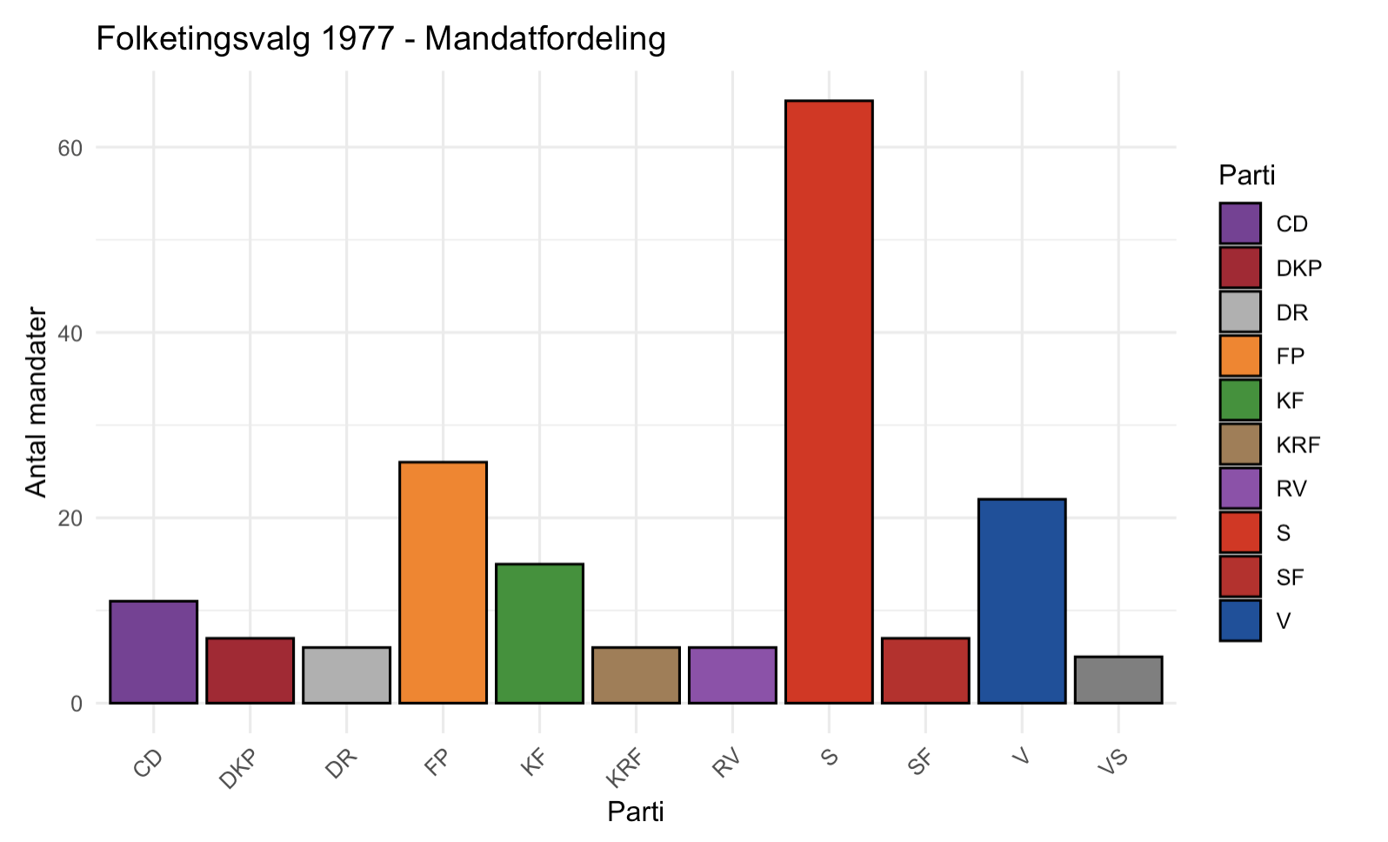

In 1984 (Chart D) KF had a rise in mandates, due to Paul Schlüter being chosen as Prime Minister, but S still has the most mandates, even though the new prime minister is from a different party. Both SF and V started to show themselves in the competition. With RV there is a blue majority, while at the same time there is an alternative majority.

*Chart D*

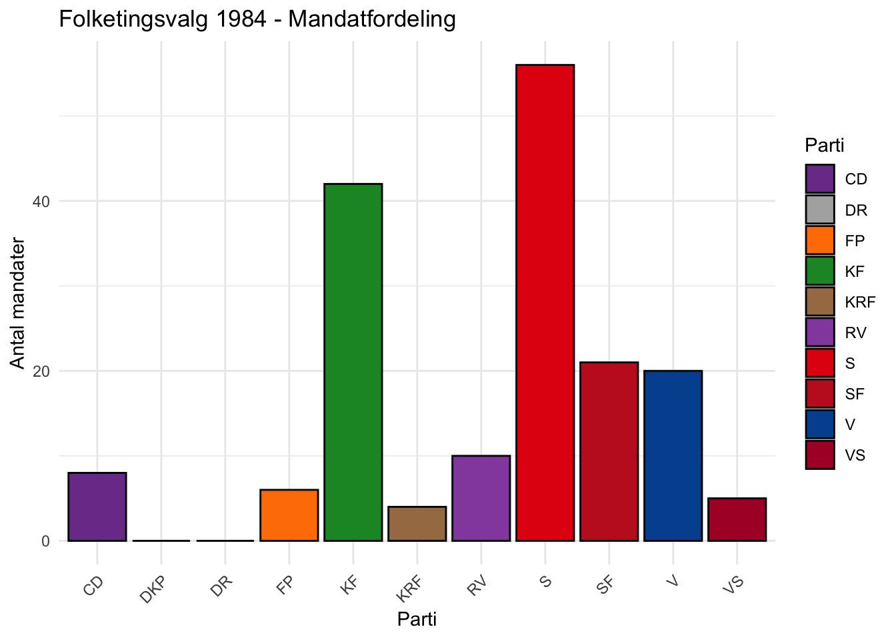

In 1994 (Chart E) V had the rise in mandates, but still not as many as S got. Compared to the previous chart, KF lost over 15 mandates, and SF is not close to the same amount of mandates to V as it was previously. V had a large rise in the numbers of mandates. There is a red majority.

*Chart E*

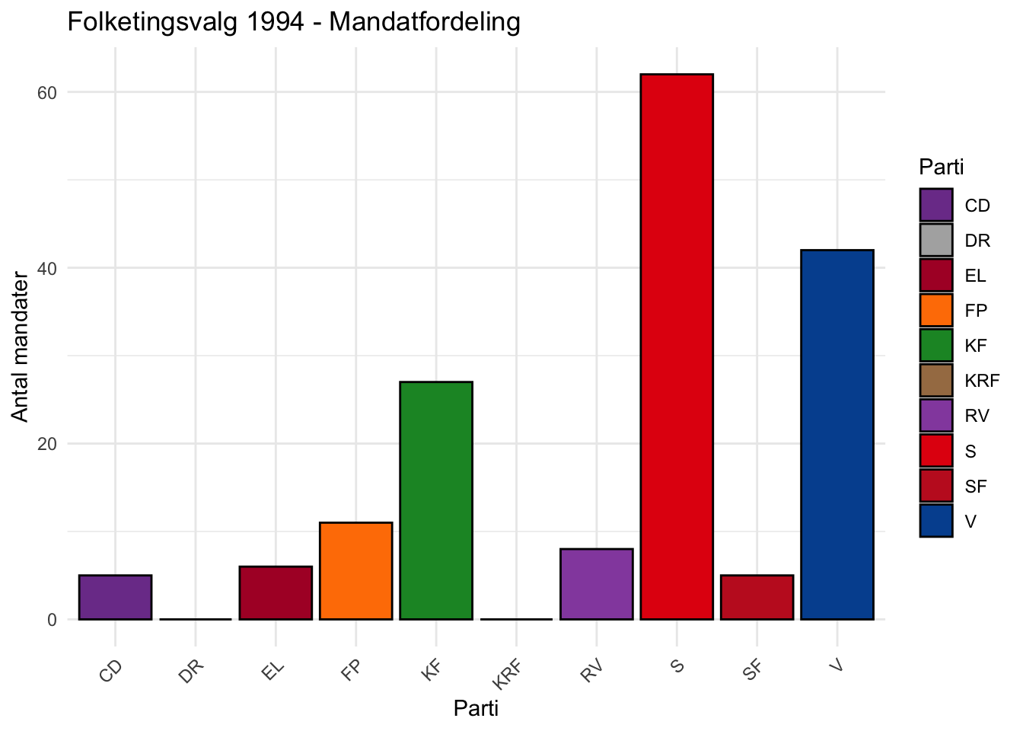

The last chart (Chart F) V won the most mandates and S is the second most. But DF and CD both show an increase in mandates. V winning the most mandates in parliament had not happened since 1920. Thus, there is also a blue majority

*Chart F*

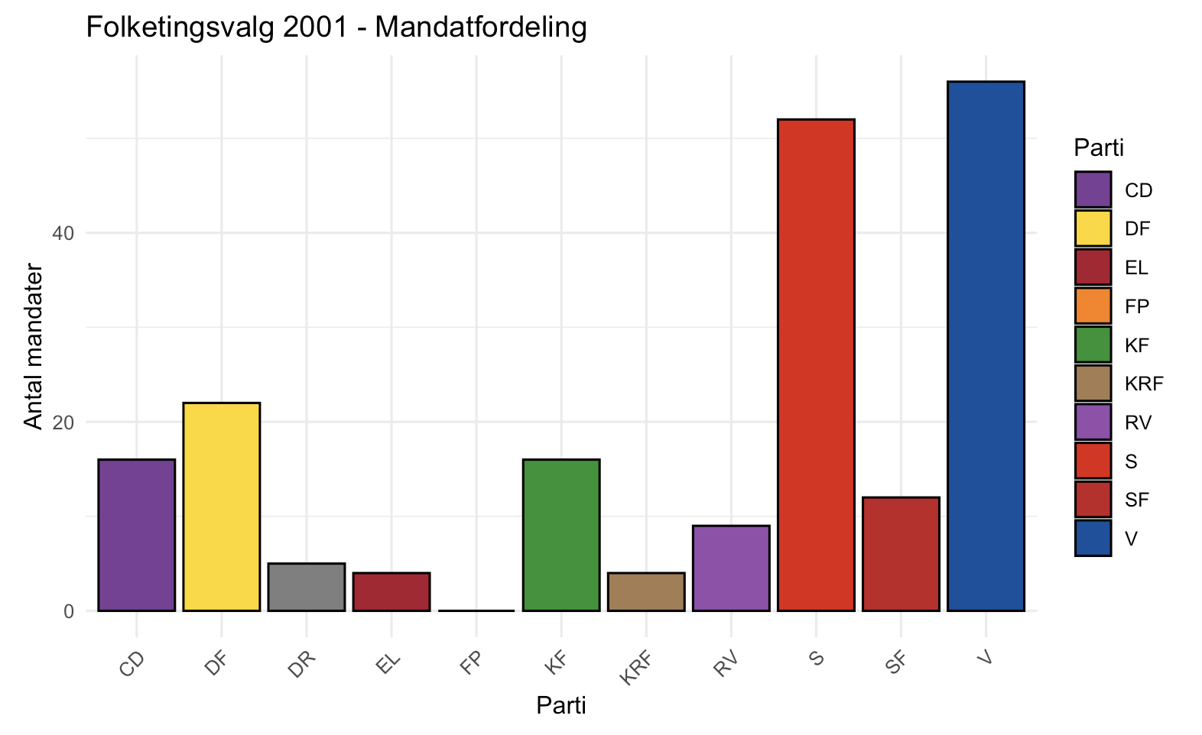

Chart A shows the Danish parties' mandates' development through the years 1973 to 2001. The X-axis is the years 1973 to 2001, and the Y-axis is the number of mandates elected. Each of the lines on the graph is colored by the party's color, and you can see the color and the names on the right side of the graph. The five black lines on the graph are the years that are shown by chart B to F.

The Charts B to F are bar charts and show the specific year. The X-axis are the different parties, and the Y-axis is the amount of mandates they got that year at the election. The different parties are colored by their parties’ color. There are a different number of parties active in the different periods, so the parties that are not active in the year shown on the graph are removed. The parties who got zero mandates are still shown, to show that the party still got votes, but not enough to get mandates. We chose to remove the “Other”-parties because they never got mandates in the period, and were just a flat line on chart A, and on the other charts it would just make it wider, but not add anything to the charts. The “Other” parties were often a single person or tiny parties.

We chose to do an animation that follows the years. The animation is the same as chart A, but the animation helps with seeing how the mandates’ amount can suddenly jump up and down the Y-axis, and you can easily follow any parties, and see how their mandates have changed in the periods.

Discussions of Results/Critical evaluation

*a.* *Significance of findings*

* 1973

Among the new parties in Jordskredsvalget were the protest parties, which arose solely on the basis that they deeply disagreed or wanted to change something in society that they did not believe the traditional parties were managing well enough. These include parties such as Fremskridtspartiet, Kristeligt Folkeparti, Retsforbundet and to some extent Centrum Demokraterne and Danmarks Kommunistiske Parti.

Socialdemokratiet had lost the desire to sit in government after a long time in power and the prospect of having a difficult time in the new parliamentary situation, even though Anker Jørgensen, chairman of the Socialdemokratiet, was elected as the negotiator for the first round of negotiations, it did not lead to anything serious. S had the support of SF and DKP, which gave 63 seats, which is not enough since you need to get up to 90 seats to not have a majority against the government. With CD and R they would have 97 seats which would be enough for the parliamentary basis for a government, but the parties each had their own reasons for not wanting to support S.[12]

The first round of negotiations was in favor of Venstre. Fp was an anarchist system-controlled party and incredibly difficult for other parties to trust as they were brand new in Folketinget and went back and forth on decisions all the time. Ultimately, Poul Hartling, who was chairman of the Venstre, did not trust Mogens Glistrup and therefore did not want to base his government on the Fremskridtspartiet for the parliamentary basis. Venstre could find a maximum of 84 seats by bypassing the FP. However, Venstre had CD and KRF behind them, which gave them 43 seats, so they had to persuade KF and R to end up with 73 seats. They bet on the last seats that they would either have S or FP's support and thus not have a majority against them.[13]

Venstre ended up forming a pure V government with this somewhat challenging parliamentary basis. Poul Hartling ends up calling an election due to the difficult situation and the Fremskridtspartiet, he ends up only serving for about 13 months as prime minister

This all shows that the new parties that have entered Folketinget are making it difficult to establish a stable government.[14]

* 1977

The parliamentary situation was very difficult in 1977, because the seats were spread across many parties from the general election in 1975, and therefore also many different opinions every time S had to negotiate in a settlement. Since Anker Jørgensen's government called the 1977 election and was only strengthened in terms of mandates, that meant the government did not have to resign and could thus remain in office. It was already a minority pure S government that had been formed in 1975. S alone got 65 mandates which is a lot, together with the parliamentary base from VS, SF, DKP and DR. That gives a total of 90 mandates and together with KF who had shown themselves willing to cooperate with the government, they had 105 mandates. All the mandates were important, however, and it quickly became apparent that the government did not always have a majority with it, which is not against the constitution, as it states that a sitting government may not have a majority against it.[15]

The 1970s in Danish politics are known for their general chaos, constant general elections and the poor economy. Despite the poor economy and a general election every other year, for most of the 1970s there was a red majority and huge support for the “Socialdemokratiet”. However, even though S was so popular, they were extremely dependent on parties like DKP, which S was not happy about. This meant that red politics had to be pursued at a time when the economy could not support it, otherwise the government would be dismissed. This naturally put a lot of pressure on S. Therefore, there was a lot of talk about forming a government across the middle, something that was otherwise only customary in extreme crisis situations such as during World War II. With Venstre's 21 mandates, the government was much stronger, even though the DKP no longer supported the government. However, it quickly became clear that this government was incompetent. They could not agree on anything, and did not trust each other. However, it is a historical government with all its entails - today, we have the same kind of government, and can look for inspiration from the parliament in 1977.[16]

* 1984

At the election in 1984, the party “Det Konservative Folkeparti" won. Neoliberalism and conservatism was an international wave that Denmark followed. But the party was a minority government, which many of the governments in Denmark are. Without RV, the government only has 83 mandates and that is why it was so important that RV supported the government because without them, the government does not have its parliamentary basis. Therefore “Radikale Venstre” and “Fremskridtspartiet” became the two parties with the most to say. “Radikale Venstre” supported the economic policies of “Konservative folkeparti” were in favor of, but as far as the foreign-, and security policy, “Radikale Venstre” disagreed much with Schlüter and his government. They adopted decisions multiple times, even though it was in disagreement with the reigning Schlüter-government. This was later called “Fodnotepolitikken”.[17]

Normally, when the government no longer has a majority, the government calls an election, but Poul Schlüter saw the economic policy as the absolute most important thing and was therefore willing to pursue the policy of “Radikale Venstre” and the rest of the alternative majority. Schlüter is known for his many quotes. Among other things, he has said "I'm not that conservative that it matters", which fits his politics very well.[18]

Because of the alternative majority, and later on the Tamil case, the press were all over Schlüter, and the people of Denmark later started to question him and his government. He kept saying that they had not done anything wrong, and that the parliament did not lie to the people of Denmark. Another very well-known quote is Poul Schlüter addressing the Danish Parliament and saying "Nothing has been swept under the carpet" (intet er fejet under tæppet).

But the accusations did not stop, and in january 1993, Poul Schlüter resigned as prime minister and the government collapsed.[19]

* 1994

In 1994 the outcome of the election ended with “Socialdemokratiet” as the leading party, and with Poul Nyrup Rasmussen as the prime minister. Poul Schlüter had in the year before resigned as Prime Minister along with his government and "Socialdemokratiet" had taken over. "Radikale Venstre" could no longer defend their footnote policy and chose to collaborate with "Socialdomokratiet"

“Radikale Venstre” kept on being an important party in the parliament. “Socialdemokratiet” and “Radikale Venstre” cooperated well together, and the good cooperation continued until 2001, where “Venstre” surpassed “Socialdemokratiet”.

"Socialdemokratiet” end up forming a government with “Centrum-Demokraterne” and “Radikale Venstre”, with a parliamentary basis from the "Enhedslisten" and "Socialistisk Folkeparti" ended they up having 94 seats.[20]

“Det Konservative Folkeparti” had been one of the biggest parties, just surpassed by “Socialdemokratiet”, in the 80’s, as you can also see in our graph from 1984. But in the 90’s “Venstre” came and surpassed “Det Konservative Folkeparti”, as you can see in our graph from 1994.[21]

* 2001

The 2001 election was held on the 20th November with the previous prime minister Poul Nyrup Rasmussen from “Socialdemokraterne” announcing it on the 31st October. He argued that Denmark needed to have an election after the 9/11 attack in North America. Anders Fogh Rasmussen (the party leader for Venstre) won the election.[22]

As shown in chart F, “Venstre”got the most mandates out of all the parties.

The election’s theme got switched from terror and foreign policies to domestic policies such as immigration policy. Anders Fogh Rasmussen and The Right Wing wished for stricter rules and policies. Other than foreign policies The Right Wing also wanted tax freezes, and an improved health and elderly care.

“Venstre”’s victory in the election and the distribution of mandates in 2001 was the first time since the 1920 election where “Venstre” was the party with the most mandates. Anders Fogh Rasmussen wanted a more centralised government and focused on the welfare state and a promised “contract” between the voters.[23]

In 1995, Pia Kjærsgaard and Kristian Thulesen Dahl founded the party “Dansk Folkeparti”, which originates from Fremskridtspartiet, and ended up being successful - at the election in 2001, it ended up being the third biggest party with the third most mandates, as you can see on *chart F*.[24]

*b.* *Evaluate*

We expected a big change in the development of parliamentary basis throughout the period from the “Jordskredsvalget” in 1973.

The graphs; B, C, D, E, F shows that“Socialdemokratiet” were the largest party in Denmark for many years up until 2001, where “Venstre” became the largest party, with the most mandates in Folketinget. But even though “Socialdemokratiet” were the largest party, the charts makes it visually clear, that the minor parties, particularly parties from the right-wing, are gaining more and more popularity and therefore more and more mandates, and ultimately Venstre, a right-wing party, ended up surpassing “Socialdemokratiet”.

In just under 30 years, we have seen a major change in Folketinget in how mandates are managed. We see, among other things, in some years how the red majority is the largest, such as in 1994 under Poul Nyrup Rasmussen and his government. We saw a blue majority in 2001 under Anders Fogh Rasmussen's government. However in 1973 we see how challenged Poul Hartling and his pure “Venstre” government were by the “Fremskridtspartiet” and ended up calling an election on it. We see in 1977 how there is actually a red majority but “Socialdemokratiet” ends up going into government with “Venstre” to be more active, even though it ends up in the opposite direction. In 1984 we see how on some issues there is a blue majority and on other areas there is a red majority. All because of the pressure from “Radikale Venstre”. It must therefore be noted that in the 70s, 80s and early 90s the parliamentary basis behind the various governments was very unstable due to external parties such as the “Fremskridtspartiet” and “Danmarks Kommunistiske Parti”. In the rest of the 90s until 2001 and that government, the larger parties had gained more control over the smaller parties and were therefore not as challenged on the parliamentary basis as in the 70s and 80s.

*c.* *Consider Utility/Representativeness*

Our results are based on data from Folketingets own data, on the database [oda.ft.dk](http://oda.ft.dk), and the data is reliably sourced from their own website. We have checked with similar sources, and the results were the same. We chose to base our own data and csv-file on the data from Folketinget’s own website, since it was the most reliable source, and had all of the numbers and percentages of the results of the elections from 1953-2022.

Our results are limited, because we chose 5 years from 1973-2001, so our project shows the change from only those years - but we chose those years, because we knew that those years are important in Danish politics. We would argue that our project is still reliable, but we show the whole graph for the chosen period.

*d.* *Lessons Learnt/New Avenues*

We discovered that even “Venstre” gained a lot of popularity in forms of mandates, very quickly in the later years of our period. We also learned that even though "Socialdemokratiet" were sometimes very large, it did not mean that they had the parliamentary basis to form a government. Some of the extreme parties on both sides, as well as in the middle, have had a huge influence on how governments have formed.

*Our investigation raised the question of how and why?*

The society was changing, and a lot of factors meant that “Venstre” became that popular, that quickly.

* They began to broaden their appeal. They wanted to appeal for people at any age, and with any job description, and no matter where they lived. Their new motto was “Time for change”, and therefore they stopped talking about privatization and user fees - he wanted to be understood by all.
* In line with his policy for a broader reach, he came up with the term “Kontraktpolitik” or contract policy, which means that when a prime minister is chosen, he has to keep the promises he makes before elected, and policy should live up to what it was all about before the election.[25]

To improve the investigation, or broaden the investigation, we could mark down some more years. If we wanted to investigate, we could look into the more recent years in the raw data from [oda.ft.dk](http://oda.ft.dk), which goes all the way up to the last election in 2022, where Socialdemokratiet won, with Mette Frederiksen as Prime Minister.

We could also look into how the mandates were distributed from the “Junigrundlov” in 1953 to the “Jordskredsvalget” in 1973, and mark down some years in that period.

Another thing we could do is compare with other Scandinavian countries in the same chosen period, and try to see if there are any similarities between parties with the most mandates. On a larger scale you could compare with Europe, and see how similar Europeans think on a parliamentary level, or how differently Europeans think in politics.

Conclusions and recommendations

Our hypothesis was that there is a big change in the development of the parliamentary basis throughout the period from the “Jordskredsvalget” in 1973 to 2001. We found the data our dataset is based on on Folketingets database [oda.ft.dk](http://oda.ft.dk). We looked it through, and selected the following years to look into; 1073, 1977, 1984, 1994 and 2001.

Then we processed the data, making it into an excel ark, and converting it to an comma-separated-value or CSV. In RStudio we visualized the data into five graphs and one animated graph, showing how the mandates were distributed in the five years we selected and chose to look into.

When we had made the graphs it became clear that overall "Socialdemokratiet" is the largest party throughout the period, but the graphs were quite different from each other beyond this point. For example, it fluctuate a lot which party was the second largest party in the Danish parliament, and even more fun is it that only at the end of 2001 was it a red party (Socialdemokratiet), otherwise it has been the "Fremskridtspartiet", "Venstre" and "Konservative folkeparti". It also showed that even though a party was the largest, it did not mean they were in government, because it is decided based on who can have the largest parliamentary base for their government.

There have also been many different parties and a single independent person throughout the elected period, some came to stay while others have left again.

Finally, we also see that "Socialdemokratiet" has lost its otherwise dominant position, throughout the period, in "Folketinget" to "Venstre".

**Author contributions**

Author Kresten Clausen came up with the topic “mandates in Folketinget”. Authors Jakob Tinmahan, Kresten Clausen and Smilla Søgaard Larsen came up with the thesis. Datacollection was done by Jakob Tinmahan, Kresten Clausen and Smilla Søgaard Larsen. Dataprocessing was done by Jakob Tinmahan. Analysis in RProject were performed by Jakob Tinmahan, Kresten Clausen and Smilla Søgaard Larsen. The first draft was written by Smilla Søgaard Larsen, and later drafts was commented on and worked on by Kresten Clausen, Jakob Tinmahan and Smilla Søgaard Larsen.

Authors Kresten Clausen, Jakob Tinmahan, Smilla Søgaard Larsen read and approved the final manuscript.

**Thank you’s**

Thank you to Andreas Emil Mikkelsen (DAM-assistant) for approving and making suggestions for improvement to the code and the report.

Thank you to Adéla Sobotkova (Course Instructor) for helping with the code and teaching the course.

**References (ikke I antal sider – ikke inkluderet)**

Thorsten Borring Olesen, *Anker Jørgensens tid 1972-1982.*, 2. udgave., De danske ministerier 1972-1993 1 (Kbh: Gad, 2019).

Niels Wium Olesen, Poul Schlüters tid 1982-1993., 2. udgave., De danske ministerier 1972-1993 2 (Kbh: Gad, 2019).

Morten. Fink-Jensen, Jes Fabricius Møller, og Niels. Wium Olesen, Historien om Danmark: Reformation, enevælde og demokrati., 1. udgave. 1. oplag. (Kbh: Gads forlag, 2017).

Bjørn Poulsen og Thorsten Borring Olesen, En danmarkshistorie : fra middelalder til nutid., 1. udgave. (Aarhus: Aarhus Universitetsforlag, 2021).

Kresten Clausen, Bredt emne eksamen, Valget i 1975, (Aarhus: Aarhus Universitet)

ChatGPT – used for consulting when working in R.

[ft.dk](http://ft.dk) – for collecting metadata, and researching on the topic.

[oda.ft.dk](http://oda.ft.dk) - used for data-collecting.

[lex.dk](http://lex.dk) - used for collecting knowledge about danish politics. We used these two pages:

<https://danmarkshistorien.lex.dk/Folketingsvalget_1977>

<https://danmarkshistorien.lex.dk/Folketingsvalget_1973>

[ft.dk](http://ft.dk) - the raw dataset we used:

<https://www.ft.dk/-/media/sites/ft/pdf/folkestyret/valg-og-afstemninger/folketingsvalg-fra-1953.pdf?fbclid=IwY2xjawKROupleHRuA2FlbQIxMABicmlkETBwTDR1T3lRbW91WlUxTktvAR5xk3smcOR91M1NXtzO64SdF_2d0HcXhVhxT1CBStbh_TWsoWA1wlJLB9aVqw_aem_MFbgJnx7QV0qUI-KUaq8DA>

“Folketingsvalget 1973”, set 9. januar 2025, <https://danmarkshistorien.dk/vis/materiale/folketingsvalget-1973>.

***B - Required Metadata (does not count towards character/page limit)***

***Table 1 – Software metadata***

|  |  |
| --- | --- |
| ***Software metadata description*** | ***Please fill in this column*** |
| *Permanent link to Github repository where you put your script(s), R project, and data* | [*https://github.com/Digital-Methods-HASS/au761990_Tinmahan_Jakob/tree/DAM-Projekt*](https://github.com/Digital-Methods-HASS/au761990_Tinmahan_Jakob/tree/DAM-Projekt)  [*https://github.com/Digital-Methods-HASS/Smilla/tree/Smilla-portef%C3%B8lje*](https://github.com/Digital-Methods-HASS/Smilla/tree/Smilla-portef%C3%B8lje)  [*https://github.com/Digital-Methods-HASS/au768361_Clausen_Kresten/tree/Eksamen-DAM%2C-Smilla%2C-Jakob-og-Kresten*](https://github.com/Digital-Methods-HASS/au768361_Clausen_Kresten/tree/Eksamen-DAM%2C-Smilla%2C-Jakob-og-Kresten) |
| *Software License* | *R:Studio. Version 2024.12.1+563 (2024.12.1+563)*  *CC-BY-SA 4.0*  *Creative Commons Attributions-ShareAlike 4.0 International*  [*https://creativecommons.org/licenses/by-sa/4.0/*](https://creativecommons.org/licenses/by-sa/4.0/) |
| *Data License* | *List one of the approved licenses, e.g. Creative Commons 4.0; see Week 17 lecture for more* |
| *Software versions, Installation requirements & dependencies for software not used in class* | *NA* |
| *If available Link to software documentation for special software (only relevant if you go outside the scope of class)* | *NA* |
| *Support email for questions* | AU761990@uni.au.dk |

***Table 2 – Data metadata (use the template below or create your own metadata table)***

|  |  |
| --- | --- |
| ***Metadata description*** | ***Please fill in this column*** |
| [*https://www.ft.dk/-/media/sites/ft/pdf/folkestyret/valg-og-afstemninger/folketingsvalg-fra-1953.pdf?fbclid=IwY2xjawJ8BU1leHRuA2FlbQIxMABicmlkETFXQ3ZJOTVYQ283ZThDdEVZAR7auZuk_xZ-znerQu0fireTc3EN7ErTYmegHyXvxcsvq2i8Uyqtt4une25E5A_aem_T1U4msDCKv_HLyiAotx9HQ*](https://www.ft.dk/-/media/sites/ft/pdf/folkestyret/valg-og-afstemninger/folketingsvalg-fra-1953.pdf?fbclid=IwY2xjawJ8BU1leHRuA2FlbQIxMABicmlkETFXQ3ZJOTVYQ283ZThDdEVZAR7auZuk_xZ-znerQu0fireTc3EN7ErTYmegHyXvxcsvq2i8Uyqtt4une25E5A_aem_T1U4msDCKv_HLyiAotx9HQ)  *Kilde til vores csv-fil* | *Folketinget’s own website*  *Uploaded by Folketingets Oplysning march 2023*  *It shows the danish parlaments votes, votes in % and mandates through the years 1953 to 2022 for each of the active party in that period, but there is more than one information per cell* |
| *Folketingsvalg-Kandidat.csv*  [*https://docs.google.com/spreadsheets/d/1_8hYTjTyaB6Wajo9daNwKmN_bioit1D4_1aACerW4jw/edit?gid=110285397#gid=110285397*](https://docs.google.com/spreadsheets/d/1_8hYTjTyaB6Wajo9daNwKmN_bioit1D4_1aACerW4jw/edit?gid=110285397#gid=110285397) | *Created by Jakob Tinmahan, Smilla Larsen & Kresten Clausen*  *It was made 28/4 2024*  *It shows the danish parlaments votes, votes in % and mandates through the years 1953 to 2022 for each of the active party in that period, where we have cleaned the data, so it is more tidy and readable compared to the original* |

1. Poulsen Bjørn m.fl., *En danmarkshistorie: fra middelalder til nutid.*, 1. udgave. (Aarhus: Universitetsforlag, 2021). (Lektion 9, Boring Olesen og Strandgaard Jensen)
2. Poulsen Bjørn m.fl., *En danmarkshistorie*.
3. Clausen, Kresten, bredt emne eksamen 2025, *Valget i 1975,* (Elev på Aarhus Universitet)
4. Morten, Fink-Jensen, Jes Fabricius Møller, og Niels. Wium Olesen, *Historien om Danmark Reformation, enevælde og demokrati.*, 1. udgave. 1. oplag. (Kbh: Gads forlag, 2017).
5. Fink-Jensen, Fabricius Møller, og Wium Olesen, *Historien om Danmark: Reformation, enevælde og demokrati.*
6. Lykkebo, Kirsten Benn. “Jordskredsvalget i 1973” [lex.dk](http://lex.dk) - Danmarks Nationalleksikon, 3. okt. 2024 <https://lex.dk/jordskredsvalget_i_1973>
7. Danmarkshistorien: *Folketingsvalget 1977* i *Danmarkshistorien* på lex.dk. Hentet 14. maj 2025 fra <https://danmarkshistorien.lex.dk/Folketingsvalget_1977>
8. Danmarkshistorien: Folketingsvalget 1984 i Danmarkshistorien på lex.dk. Hentet 15. maj 2025 fra https://danmarkshistorien.lex.dk/Folketingsvalget_1984)
9. Poulsen Bjørn m.fl., *En danmarkshistorie*.
10. Poulsen Bjørn m.fl., *En danmarkshistorie*.
11. Poulsen Bjørn m.fl., *En danmarkshistorie*.
12. Thorsten Borring Olesen, *Anker Jørgensens tid 1972-1982.*, 2. udgave., De danske ministerier 1972-1993 1 (Kbh: Gad, 2019).
13. Borring Olesen, *Anker Jørgensens tid 1972-1982.*
14. Borring Olesen, *Anker Jørgensens tid 1972-1982.*
15. Borring Olesen, *Anker Jørgensens tid 1972-1982.*
16. Borring Olesen, *Anker Jørgensens tid 1972-1982.*
17. Poulsen Bjørn m.fl., *En danmarkshistorie*.
18. Niels Wium Olesen, *Poul Schlüters tid 1982-1993.*, 2. udgave., De danske ministerier 1972-1993 2 (Kbh: Gad, 2019).
19. Poulsen Bjørn m.fl., *En danmarkshistorie*. (Lektion 9, Boring Olesen, Strandgaard Jensen)
20. “Folketingsvalget 1994”, Danmarkshistorien | Lex, 24. marts 2025, https://danmarkshistorien.lex.dk/Folketingsvalget_1994.
21. Poulsen Bjørn m.fl., *En danmarkshistorie*.
22. *Folketingsvalget 2001*, i Danmarkshistorien, lex.dk: <https://danmarkshistorien.lex.dk/Folketingsvalget_2001>).
23. Poulsen Bjørn m.fl., *En danmarkshistorie*.
24. Poulsen Bjørn m.fl., *En danmarkshistorie*.
25. Jens Ringberg, “Historien om Venstre”, [dr.dk](http://dr.dk): <https://www.dr.dk/nyheder/webfeature/venstre>